**\*PRODUCT DESIGN THINKING**

**\*QUANTUM UNIVERSITY**

**\*ASS NO.3 (TASK 2)**

**\*Create a extempore**

# **TASK 02**

### **IT in Automobiles**

The automobile industry is undergoing a major transformation with the integration of **IT, AI, and semiconductor-based embedded systems**. Modern vehicles are equipped with **Electronic Control Units (ECUs)** that manage everything from engine performance to driver assistance features. **Advanced Driver Assistance Systems (ADAS)**, powered by **real-time data processing and machine learning**, enable features like lane-keeping assistance, adaptive cruise control, and automatic emergency braking. **Semiconductors play a key role** in electric vehicle (EV) battery management, autonomous driving technologies, and **Vehicle-to-Everything (V2X) communication**, which allows cars to interact with infrastructure, pedestrians, and other vehicles. The integration of **IoT and 5G connectivity** has also enabled **over-the-air (OTA) software updates**, ensuring vehicles remain up to date with the latest software and security patches.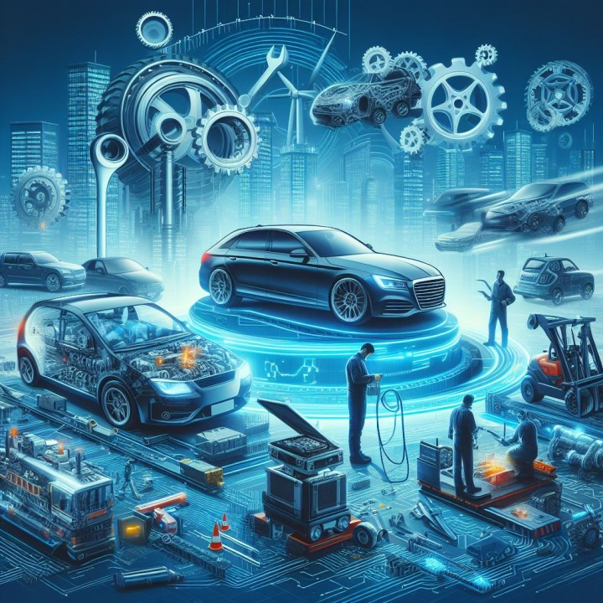

### **IT in Metro Rail**

The metro rail sector relies on **semiconductor-based embedded systems** for automation, real-time monitoring, and safety. **Automatic Train Control (ATC) and Communication-Based Train Control (CBTC)** systems ensure efficient train operations by optimizing speed, signaling, and track switching. **Smart ticketing systems**, using **RFID, NFC, and biometric authentication**, enable contactless entry and seamless passenger flow. Metro networks also use **IoT-based sensors** for predictive maintenance, ensuring early fault detection in tracks, rolling stock, and electrical components. **SCADA (Supervisory Control and Data Acquisition)** systems manage power distribution and ventilation within tunnels, ensuring a smooth and safe ride. The adoption of **AI-driven traffic management systems** further optimizes train frequency, reducing congestion and improving energy efficiency.

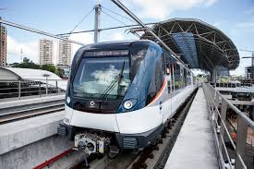

### **IT in Avionics**

Aviation depends heavily on **high-performance computing, semiconductor-based avionics systems, and AI-powered automation**. **Flight management systems (FMS)** rely on advanced microprocessors for navigation, autopilot functions, and fuel optimization. **Real-time avionics software** enables precise **GPS-based navigation**, allowing aircraft to follow optimal flight paths while reducing fuel consumption. **Semiconductors power radar systems, collision avoidance technology, and in-flight connectivity**, ensuring both passenger safety and enhanced travel experience. Ground operations benefit from **air traffic management software, baggage tracking systems, and AI-powered predictive maintenance**. The latest advancements include **More Electric Aircraft (MEA)**, which replace traditional hydraulic systems with semiconductor-based electric actuators, reducing weight and improving fuel efficiency.

